Write a Scala application to find the Nth digit in the sequence.

○ Write the function using standard for loop

○ Write the function using recursion

Using Loop

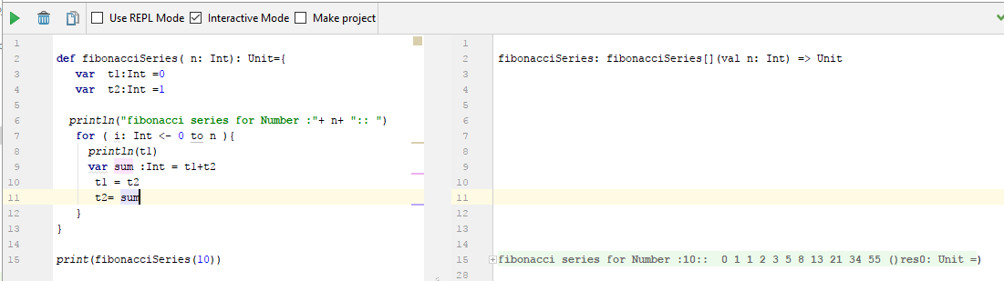

Using Recursion

